PROJECT DESIGN PHASE-II

TECHNOLOGY STACK (ARCHITECTURE & STACK)
Date: 26 September 2026
Team ID: SWTID-2026-3332
Project Name: AI FAQ Assistant API
Maximum Marks: 4 Marks
Technical Architecture
The AI FAQ Assistant API is a REST-based web application architecture. Client requests are sent from the frontend application or API testing tools to the Node.js and Express.js backend. The requests are processed through authentication, validation, and error-handling middleware before reaching the appropriate controller and service layer.
The application uses MongoDB with Mongoose for storing user and FAQ information. JWT is used for authentication, while bcrypt is used for secure password hashing. Google Gemini is integrated as the external AI service for generating AI-powered answers and FAQ question-answer pairs. The system also provides keyword-based FAQ search across FAQ questions, answers, and categories.
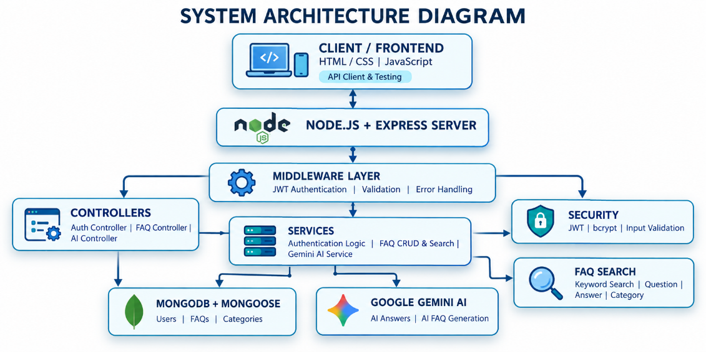

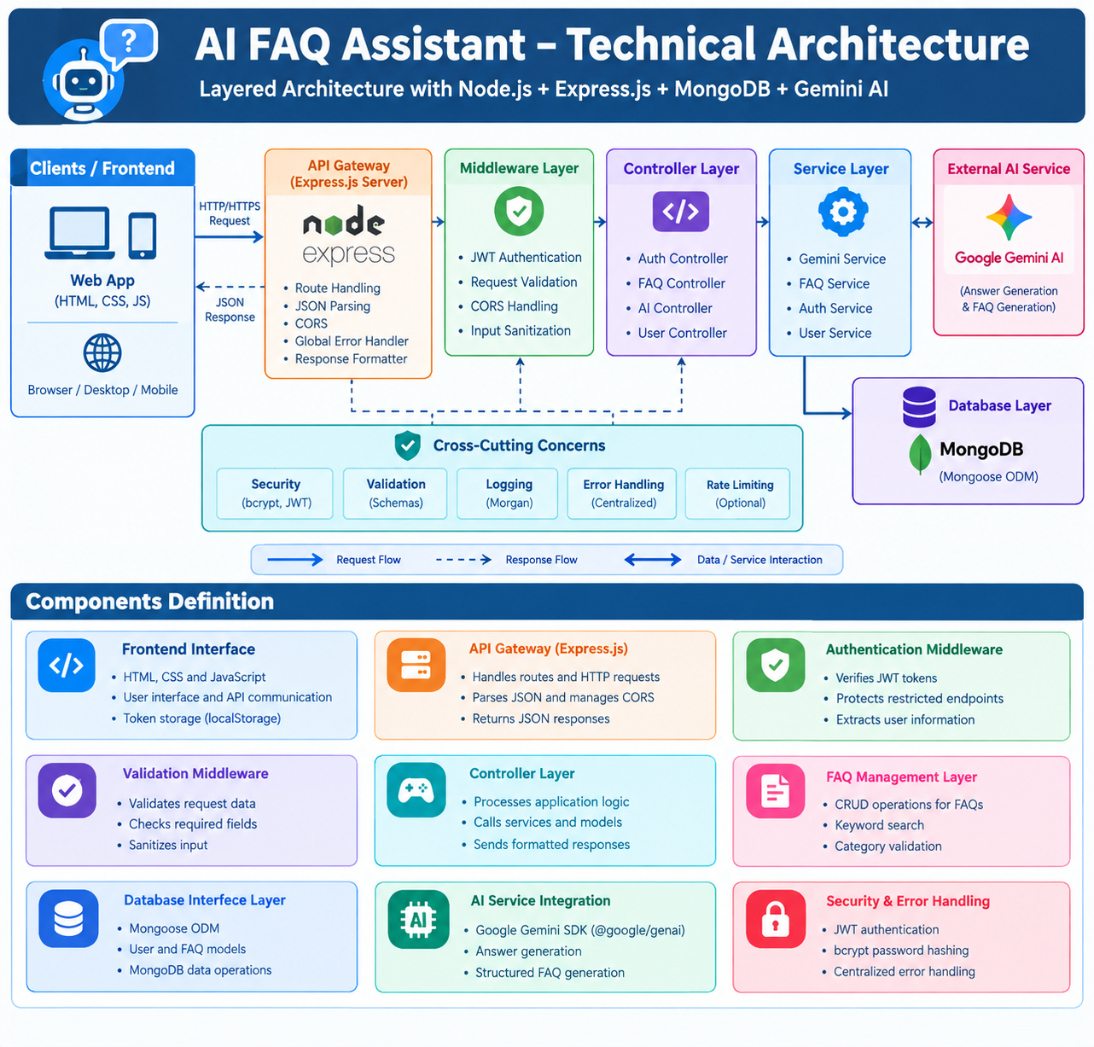

Table 1: Components & Technologies
S.No | Component | Description | Technology
1 | User Interface | Web interface through which users interact with the FAQ and AI features | HTML, CSS, JavaScript
2 | Application Logic-1 | Handles REST API routing, request processing and application flow | Node.js, Express.js
3 | Application Logic-2 | Handles user authentication, JWT verification and password security | JWT, bcrypt, Express Middleware
4 | Application Logic-3 | Handles FAQ management, FAQ search, AI answers and AI FAQ generation | Express Controllers, Services, Google Gemini API
5 | Database | Stores registered users and FAQ information | MongoDB, Mongoose
6 | Cloud Database | Cloud-hosted database option for application data | MongoDB Atlas
7 | File Storage | Not required for the current FAQ application | Not Applicable
8 | External API-1 | Generates AI-powered answers and FAQ question-answer pairs | Google Gemini API
9 | External API-2 | No additional external API is used | Not Applicable
10 | Machine Learning Model | Provides AI-based processing for question answering and FAQ generation | Google Gemini AI Model
11 | Infrastructure (Server / Cloud) | Backend runs through a Node.js server while database and AI services can use cloud infrastructure | Node.js Server + MongoDB Atlas + Google Gemini

Table 2: Application Characteristics

S.No | Characteristics | Description | Technology
1 | Open-Source Frameworks | Backend development uses open-source runtime, framework and database technologies | Node.js, Express.js, Mongoose
2 | Security Implementations | Protects user accounts and APIs using authentication, password hashing and request validation | JWT, bcrypt, Express Middleware
3 | Scalable Architecture | Modular architecture separates routes, controllers, services and database operations, allowing additional FAQ and AI features to be added independently | MVC, Express.js, Service Layer, MongoDB
4 | Availability | Database and external AI services can be accessed whenever the backend and required services are available | MongoDB Atlas, Google Gemini API
5 | Performance | Uses structured API operations, database queries and keyword-based search to process FAQ information efficiently | Mongoose, MongoDB Queries, FAQ Search

Technology Stack Summary

Backend
Node.js + Express.js
Frontend
HTML + CSS + JavaScript

Database
MongoDB Atlas + Mongoose

Authentication
JWT + bcryptjs

AI
Google Gemini API

FAQ Search

Keyword-based FAQ Search

AI Question Answering
Google Gemini AI

API Testing
Thunder Client
Development Environment
Visual Studio Code

